**Canadian language attitudes from “coast to coast to coast”: on the pluricentricity of English in North America**

Stefan Dollinger & Lars Hinrichs

# 1 Introduction

The present paper explores various aspects of the linguistic autonomy and the character, recognition and social embedding of “Standard Canadian English” and various related aspects. A focus on the standard of a given context, its conceptualization, perception and discursive construction is sociolinguistically relevant for a number of reasons. One can argue that attitudes towards a standard variety shape other aspects of linguistic practice. As sociolinguists are not immune to wider social developments we may expect shifting interpretations over time. For instance, while the first generation of Canadian linguists tended to emphasize differences (e.g. Avis et al. 1967, Scargill 1974) between Canadian English and other varieties, above all American English, the linguistics of Canadian English has seen a different effect in the era of the free trade negotiations of the 1980s and early 1990s[1]. This period was marked by statements as to the weakness of Canada-US border as a linguistic divide (e.g. Chambers 1980, Warkentyne & Brett 1981: 307, Warkentyne 1983: 73), or even to its irrelevance (e.g. Woods 1993: 174). The latter point may occasionally be echoed in more recent writings (e.g. Sadlier-Brown 2012: 547).

What generally unites these claims, however, is the lack of a comparative US sample in addition to Canadian samples, which means that US usage is inferred from indirect evidence (e.g. dictionary and usage guides, or general impressions) but not data collected in the same way as on the Canadian side. Whenever a more rigorous design is brought to study cross-border linguistic influences, however, it is almost always shown that the veracity of the Canada-US border and its linguistic effects – subtle yet consistent – is evident (e.g. Chambers 1994, 2000; Boberg 2000, Boberg 2005, Boberg 2008; Dollinger 2012) and the pluricentric character of North American English – with a dominant US Standard and a non-dominant Canadian Standard – is accepted.

In the context of pluricentric languages, it is noteworthy that “contiguous varieties” of the same language, such as Canadian and American English, or, in the European context, Austrian German and German German or Netherlandic and Belgian Dutch, have traditionally been faced with disciplinary scepticism (e.g. Koppensteiner & Lenz 2020, Scherr & Ziegler 2023). In the North American context, occasion sub-grouping into a “North American English” might occur as a type, but the recognition of Standard Canadian English as distinct from Standard American English has been handbook lore for decades (e.g. Trudgill & Hannah 2017: 54-56 and previous editions).

In this context, “non-contiguous varieties”, i.e. those separated by a sea border such as Australian and New Zealand English, or Irish English and English English, have been recognized more easily. Such questions of dominance (heteronomy) or non-dominance (autonomy) are part and parcel of the sociolinguistic theory of linguistic pluricentricity (e.g. Clyne 1984, 1995, Ammon et al. 2004, Muhr 2012, Dollinger 2019b).

Based on a language attitudinal questionnaire, the present paper explores notions of the “standard” for Canadian English and notions of linguistic autonomy as central tenets of pluricentric theory. It is structured in the following way: after a brief overview of existing attitudinal work on Canadian English, we will first introduce the constraints of the present data set, collected in late 2023. We will then present the main results, correlations and modelling effects for the 3000-respondent-survey. In a next step, the findings will be put into the context of existing literature on language attitudes and perceptions and Canadian English, before they are interpreted in the larger framework of the sociolinguistic theory of pluricentricity, which is occasionally critiqued as nationalistic (e.g. Schneider 2022) or more generally misunderstood (e.g. Elspaß 2025, Herrgen 2015). It will be highlighted that pluricentricity has been the dominant approach in the sociolinguistics of World Englishes and that other concepts, purported to stand in competition or to “complement” pluricentricity, appear in philological frames that not only face decolonial or dehegemonic challenges (e.g. Oakes 2021, Dollinger 2025a, 2025b) but that appear to be epistemologically fraught (Dollinger 2019b). Where conducive, findings from other pluricentric settings will be brought to bear to highlight the special role of what since Clyne (1992) and Muhr (2012) are often referred to as “non-dominant” varieties.

As pluricentric modelling does not lend itself well to data-driven perspectives that disregard the social salience of variables and speaker attitudes (e.g. Elspaß et al. 2025, Scherr & Ziegler 2023), we recognize the central role of speakers’ cognitive representation of multiple standard varieties in North America. Following de Cillia & Ransmayr (2019), we employ non-linguistic terminology in our questions to probe the identification, conceptualization, and acceptance of a non-dominant standard variety, in our case Standard Canadian English (StCanE) in opposition to Standard American English, as indicative of multiple standards and thus linguistic pluricentricity in North America.

# 2 Literature

Following pluricentric theory (Leitner 1992), two English varieties can be considered dominant today: Standard English English and Standard American English. All other varieties, including Standard Canadian English, are non-dominant varieties (e.g. Clyne 1992, originally called “dominant” and “other” varieties”) and are particularly prone to the effects of linguistic insecurity (Preston 2013). It is one purpose of this study to assess the belief of Canadians in the linguistic autonomy of their own standard, Standard Canadian English.

Few studies have hitherto investigated the phenomenon of linguistic attitudes and have either focussed on impressionistic assessment or focussed on the linguistic insecurity among Canadian English speakers. Chambers (1986) finds that Canadians, due to variation in spelling, are not favourable towards linguistic standards, while Owens and Baker (1984: 349) suggest that Canadian English was Americanizing in the early 1980s, although still 1 in 4 Winnipeggers considered the British form as “correct”.

Earlier attitudinal work sought to correlate measurements of attitudes towards country and statehood with linguistic features. Warkentyne (1983) and Gulden (1979) report on the same study, conducted in 1977 at the University of Victoria undergraduate in linguistics cohort. Gulden (1979: 45) reports on 64 students, while Warkentyne (1983: 72) speaks of “68 Canadian-born in two introductory English linguistics courses”, and “most of them indicated” to be “preparing for a career as teachers of English” (Gulden 1979: 45). Their results, however, are identical, deriving from one and the same study.

**The 1977 UVic student study**

The UVic study assessed on the one hand respondents’ general attitudes towards Canada, the US and the UK and on the other measured more specifically Canadian national identity with three questions:

[a] questions about an obligation to buy Canadian products,

[b] an evaluation of Canadian-produced TV programmes,

[c] and a direct question about the existence of a Canadian national identity

(Gulden 1979: 57)

The study assessed attitudes on a scale from -1 (negative) to +1 (positive). General national identity was assessed at +0.292, so slightly positive in this student cohort of a median age of 23, while for the linguistic items the score was lower with +0.193, leading the researchers to conclude that “This group of Canadians does not feel very strongly about speaking a distinctive variety of English called Canadian English” (Gulden 1979: 58, Warkentyne 1983: 73, Table 1). The linguistic assessment was based on the following questions:

1. Is the language of CBC announcers the standard for spoken Canadian English?
2. Should a Canadian be offended if people from other countries consider him to be an American?
3. How should he feel if taken for British?
4. Does it make sense at all to speak of Canadian English as different from American and British English?

Answer options appeared in six intervals from -1 (negative) to +1 (positive). Some of these questions appear somewhat loaded (“does it make sense at all”; would a classification of Canadians as Americans “offend” a Canadian) and were replaced in the present study with there-extrapositions or Yes/No questions on Likert scales.

Interesting in this context is the finding that questions “asking about Canadian identity directly show the most positive answers” (ibid: 58), which would relate to questions [c] and [g] above. For question [c] the value is +0.563, for the linguistic identity, [g], it is +0.344. It is possible that the rather negative framing of [g] underreported linguistic identity assessments, leading Gulden to summarize that “Canadians, or at least the present group, seem to believe in their national and linguistic identity, possibly more so than the low value of the entire [compound] variable would suggest” (ibid: 58) and lists as possible causes “an unfortunate choice of questions an/or by intervening factors such as modesty or insecurity” (ibid: 109). We have reason to assume that the linguistic insecurity needs to be mitigated against especially in non-dominant standard variety settings, such as Canadian English.

The study’s general national identity results, however, do not always fare positively for Canadian-ness. As Table 1 shows, the teacher’s degree students rated the U.S. “higher as a country in general” over Canada (ibid: 115), and, more strongly so, the U.K. over Canada and the U.K over the US:

|  |  |
| --- | --- |
| 1. Preference ratings |  |
| US (-1) vs. Canada (+1) | -0.219 |
| UK (-1) vs. Canada (+1) | -0.382 |
| UK (-1) vs. US (+1) | -0.395 |
| UK (-1) vs. US (+1) benefits | -0.307 |
| 1. Canadian national identity | +0.292 |
| Canadian linguistic identity | +0.193 |
| 1. Personality ratings |  |
| Americans | +0.129 |
| British | +0.222 |
| Canadians | +0.205 |

Table 1: Attitudinal ratings in 1977, UVic students (Warkentyne 1983: Table 1)

The fourth line in the preference ratings refers to impressions of the perceived benefits that an association with the UK or the US offers to Canada. In 1977, this sample was clearly on the UK side. More generally, British people were rated more positively than Canadian people, but the Americans the lowest. Warkentyne comments that the “low scores on the items concerning Canadian identity should allay any fears that nationalism may be carried to the extreme” (1983: 73). Discussing correlations, including those about self-ratings and satisfaction in general, Gulden concludes “a striking combination”: “those who do not have a very high opinion of themselves or any other people (except Americans) are more likely to favour the U.S. over the U.K.” and those who show a high self-evaluation “are correlated with a preference for the U.K. over the U.S.” (ibid: 123-4).

**The 2000s: an increase of Canadian linguistic awareness**

A generation later, studies that use direct questions to assess respondents’ attitudes towards linguistic autonomy found that they had markedly improved, with considerable majorities offering affirmative responses. A 2009 Vancouver study found that:

* 81% believed that “there is a Canadian way of speaking English”
* 73% claimed to be able to “tell Canadian English speakers from American English speakers”
* 69% considered “Canadian English are part of [their] Canadian identity”
* 74% wanted Canadian English “taught in schools, using Canadian dictionaries, grammars etc.” (2009 data, Dollinger 2020: Table 4.5)

Positive assessment can also be seen in terms of domestic linguistic attitudes. McKinnie & Dailey-O’Cain (2002) polled Ontarians’ and Albertans’ assessments of “pleasantness” and “correctness” of varieties of Canadian English. In terms of “correctness”, both Albertans and Ontarians consider BC English as most correct (ibid: 283). A paper on 6–12-year-old elementary students and their parents in BC and Alberta found that 69% considered the Standard Canadian English speaker as “sounding Canadian”, while the Mandarin and Cantonese-accented speaker scored 26 and 23% respectively (Dollinger, Chan, Pasula & Maag 2024: 326). This difference shows “a bias towards a StCanE accent which we attribute to the forcefulness of standard language ideology in Canada” (ibid). It was also shown that “the multilingual speaker is less tolerant towards L2-accented English than monolingual speakers” (ibid: 329).

What is available to date for assessments of Standard Canadian English are province-related findings from Manitoba, Alberta, Ontario and BC, but no study of national scope. The present study aims to fill this void by including data from all provinces and territories. It intends to gauge to what degree “Canadian English has become a reality for many of its speakers” (Dollinger 2019a: 224).

# 3 The data

The data was collected with a questionnaire of 25 language attitude and usage question, which was complemented by 14 social background question. Data was collected with 18 students in an upper level English linguistics seminar at UBC (ENGL 489, Language Majors Seminar) in November and December 2023. The questionnaire can be accessed online.[2] Over 3000 responses were collected, from all ten provinces and three territories, of which up to 3001 were used in the analysis. Table 1 shows the absolute numbers of responses by place of residence (Live now) and formative region, that is the region in which at least 9 years during the formative years 0-18 were spent. Because of low returns from residents of the territories (one from Nunavut (1) and case numbers in the mid-teens from Yukon and Northwest Territories), we created a class for “north of sixty” territories, TR.

|  |  |  |
| --- | --- | --- |
| **Province/Territory** | **Live now (n)** | **Formative region (n)** |
| BC | 628 | 444 |
| AB | 663 | 506 |
| SK | 277 | 278 |
| MB | 327 | 295 |
| ON | 450 | 520 |
| QC | 123 | 105 |
| NB | 47 | 36 |
| NS | 46 | 45 |
| PE | 62 | 45 |
| NL | 42 | 42 |
| TR | 35 | 10 |
| **Canada total** | **2700** | **2326** |
| US | 93 | 127 |
| UK | 0 | 32 |
| others | 208 | 482 |
| **TOTAL** | **3001** | **2967** |

Table 1: Absolute frequencies: locations

Response numbers by age and gender are depicted in Figure 1. As can be seen, the cohort 20-24 is best represented, with females typically outnumbering males. Non-binary respondents are best represented in the cohorts from 20-49.

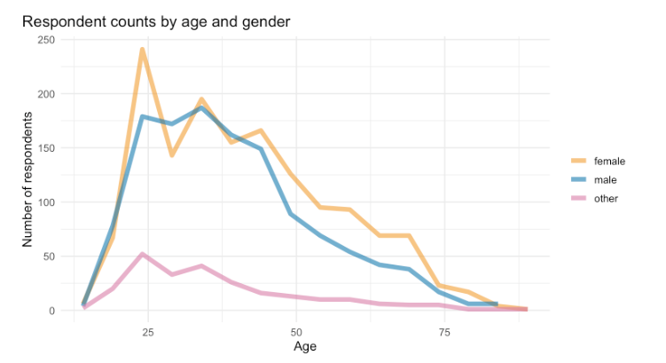

Figure 1: Absolute frequencies: age and gender for formative years in Canada

# 4 Results & Discussion

In the first section we aim to connect public discourse and use of language reference tools with the language attitudinal data. We will use several single variables and some indices that will, overall, allow us to interpret the strength of the notion of “Canadian English” as a standard variety in the minds of its speakers and with it the role of the pluricentricity of English in North America.

**Attitudinal autonomy in CanE**

Figure 2 offers an overview of six key questions among Canadian residents (this includes transient residents, e.g. foreign students). Combining the answers of “Definitely yes” and “Probably yes”, a “Canadian way of speaking” is confirmed by 70.1%, with 9% undecided. Compared with 81.1% from 2009 from a six-point scale, the present five-point scale probably more closely reflects the actual state of attitudes. Similar percentages, 68% or more than two thirds, see CanE as a “distinct kind of English”, like American or British English. On the question of spelling, the sample is more divided, with more undecided ones (26.4%) than definite yeses (24.8%). This is somewhat add odds with almost 39% “definitely” confirming that Canadian universities should encourage Canadian spelling and a clear 78% wish to have a Canadian spelling option in software applications, with 12% undecided. Lastly, in terms of a free digital dictionary of CanE, nearly 71% claim they would use it.

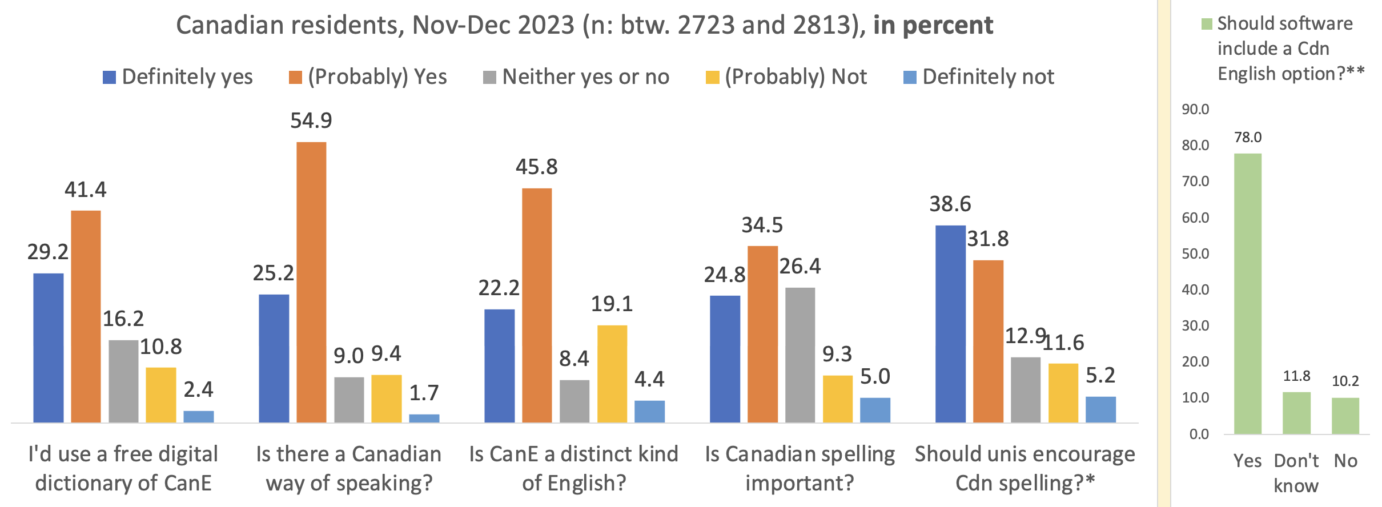

Fig. 2: Majorities confirm questions on the linguistic autonomy of CanE among the Canadian residents.

With such answers the linguistic autonomy of Standard Canadian English seems well enshrined at this point, confirming the 2009 data overall and showing considerable differentiation from the early 1980s, when “Americanization” was the most virulently discussed attribute of Canadian English. This change in outlook is remarkable and warrants a closer look at the social distribution of those who recognize Canadian English – most commonly through its standard that was documented and fully codified – as a distinct variety of English – by 1967 (Gregg 1993, Dollinger 2019: 131-32).

**Familiarity with “Standard Canadian English”**

While “Canadian English”, as a slur, dates back to 1857 (DCHP-3, s.v. “Canadian English”), “Standard Canadian English” (StCanE) is a concept that has been discussed in linguistic circles only since the 1970s. It is in pluricentric theory the key concept whose understanding is a *sine-qua-non* for an appreciation of the linguistic autonomy of a variety, i.e. Canadian English. In the public and in schooling, however, uptake of StCanE as a term and autonomous concepts has been slower. While the public perception of a “Canadian English” has been strong, even that discourse is subject to considerable fluctuation. Figure 3 (left) shows data to that effect, which correlates the use of Canadian dictionary titles in domestic media since the 1970s with the frequencies of the term “Canadian English” (“Canadian Newsstream” database) from 1980 to the end of 2024, shown in Figure 3 (right).

|  |  |
| --- | --- |
|  |  |
| Figure 3: Canadian dictionary titles and the phrase “Canadian English” in the Canadian press, 1977-2024 | |

In general, the 1980s and 1990s were a period of increasing language awareness in Canada, with the uptake of Canadian dictionary titles lagging behind an increase or decrease of the phrase “Canadian English” in the media by a period of five years. The more the concept is discussed, the more Canadian dictionary titles are used as reference sources in the media. The years 1996-1998 have been the most productive years in Canadian English dictionary publishing so far, with four full-size titles appearing. The sole winner, the *Canadian Oxford Dictionary* of this Canadian dictionary war, however, was shut down in 2008, which led to US titles being the most prevalent ones, as Figure 3 (left) shows.

That is a much detail as can be extracted from corpus searches. We aim use the current study to fill in some gaps in interpretation. Figure 4 summarizes the respondent’s general familiarity with the term “Standard Canadian English” or “Canadian Standard English” by region, that is by their formative years (“have you heard the term…”). We assigned a province/territory or country to those who spent at least nine years in their ages 0-18 in one location.

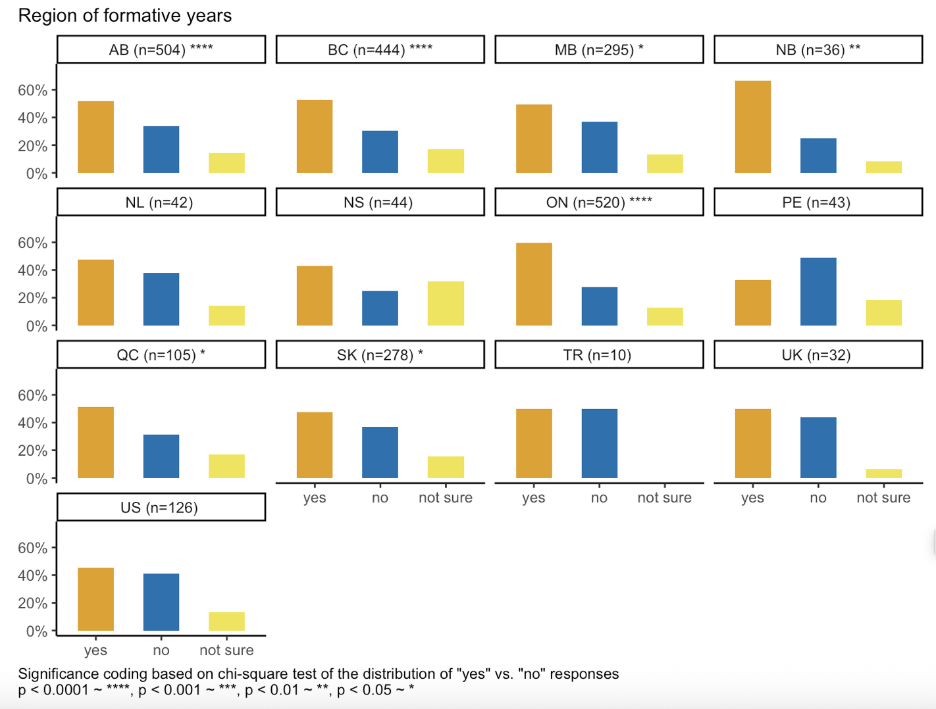

Fig. 4: “Have you heard of either “Standard Canadian English” or “Canadian Standard English”?

Figure 4 shows 10 Canadian provinces (BC to NL) and one plot for the three Canadian Territories (TR), followed by the UK, US and “other” (rest of the world) respondents (the latter will henceforth be discarded). Most often respondents reported having heard the term in New Brunswick (NB),[3] followed by Ontario (ON), British Columbia (BC), Alberta (AB), Quebec (QC) and the Territories (TR). The UK respondents are more exposed to the term than people raised in Manitoba (MB), Newfoundland and Labrador (NL) and Saskatchewan (SK).

The Americans (US) in our sample, all of whom likely with some ties to Canada as an artefact of our data collection method (snowball method), are more familiar with the term than Nova Scotians (NS) and Prince Edward Islanders (PE). The latter fare worse than the international crowd (“other”). The assumption is that if speakers are familiar with Standard Canadian English they are more likely to comprehend the social relevance of the variety as a marker of identity. Such awareness would therefore be strongest in New Brunswick (which sets it apart from the other Atlantic Provinces NS, PE and NL), followed by Ontario, then BC and Alberta.

Figure 5 shows exposure to “Standard Canadian English” with respondents’ status of multilingualism. Monolingual speakers, socialized in Canada, are significantly less likely to “have heard” of “Standard Canadian English” or “Canadian Standard English”. Monolinguals are more likely to have a “default” of “English unspecified” as a variety and need to learn to appreciate the special characteristics of Standard Canadian English.

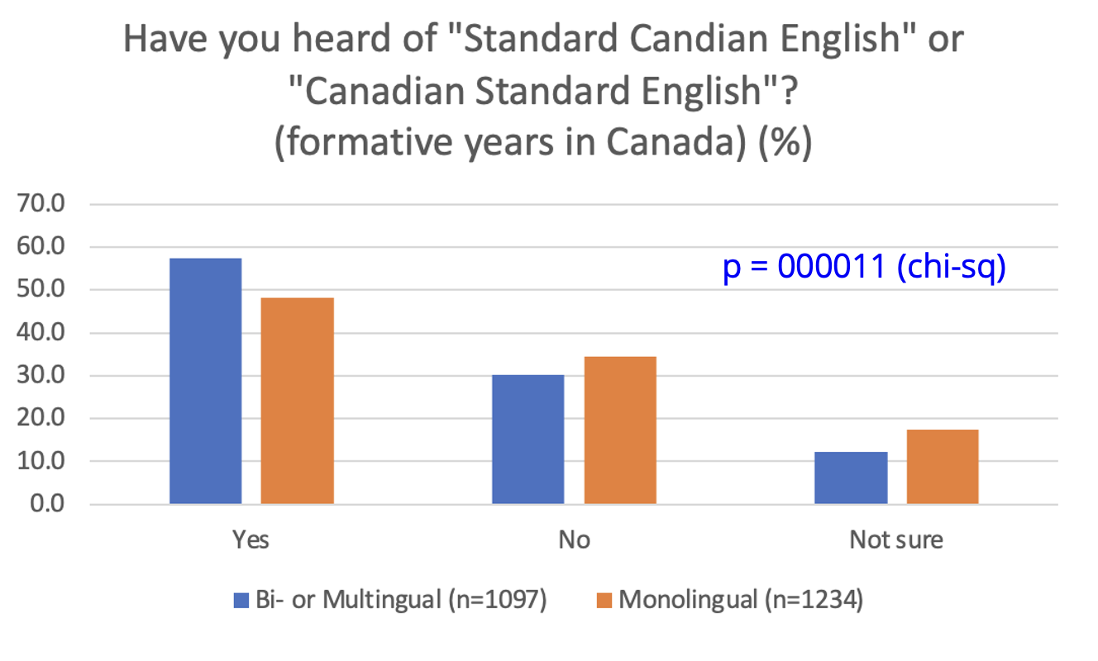

Figure 5: Heard of StCanE and Yes/No Monolingual

Figure 5 shows that Multilinguals who were raised in Canada are significantly more likely to have heard about Standard CanE. What, however, do they understand by the term, which is used in specialist circles, but very little in public discourse today (Figure 3 right, 2020-24 period)?

An open answer field solicited definitions of Standard Canadian English, with the options to decline (“don’t know what it is”, “do know it but cannot describe it well”), should yield only the answers of the confident respondents in that aspect, some of which are reproduced in Table 2 below:

|  |  |
| --- | --- |
| Definition of “Standard Canadian English” | Social characteristics |
| 1. “English used **across the country**” | 15-19, US-raised, female now in Montreal for UG), fluent English & Spanish, French advanced; Ashkenazi |
| 1. “It's a **normalised pronunciation** of English that one would hear in somewhat formal broadcasts from the **CBC**” | early 60s, male, but L2 multilingual, English & French fluent, Italian intermediate, Spanish & Chinese beginner |
| 1. **Useless spelling** when the **USA** is right next door and is most of our media | Bilingual Quebecker, lived in QC, BC and in the USA during formative years, 30-34, male. |
| 1. “I assume it is the Canadian English **of the dominant group (socially, in number)** and that corresponds to what one would hear in **mainstream media**.” | Montrealer, 50s, female, Francophone + Anglophone (Bilingual in the official sense), intermed. Italian |
| 1. English but with **Canadian (more British)** spellings and vocab, maybe pronunciation. | University student in 2nd year, 15-19, male, from Edmonton, AB, monolingual |
| 1. It is the English that includes words used in a **Canadian context**, or spelled in the way Canadians are accustomed to spelling them. | Nanaimo, female BC resident, 40-44, grew up in Ontario, Anglophone with intermediate French |
| 1. Canadian English per the **Canadian Oxford dictionary**. Or **"CBC English"** | BC resident, female, 30-34, grew up in Calgary, AB, multilingual |
| 1. The English dialect largely spoken in **Ontario and western Canada** | Saskatchewanian, male, 30-34, multilingual (fluent in English, French); Spanish, Japanese, Mandarin (intermediate) |
| 1. It is the standard dialect used in Canadian classrooms, by **Canadian media**, by **Canadian government**, etc. | Montrealer, Italian-Canadian, 20-24, multilingual |
| 1. English spoken by people who primarily **grew up** or acquired their English **in Canada** | Chinese-Canadian Montrealer, fluent in Mandarin and English, intermed. French, 20-24 |

Table 2: Select responses to the question “Do you know what “Standard Canadian English” is?

Of the ten descriptions of Standard Canadian English, notions of widespread use (1, 4, 6), media (2, 4, 7, 9), more British influence (5), a regional dimension (8) and socialization in Canada (10) are recurring themes, with occasional sceptics (3). What is striking is that the attribute of “educated”, normally a mainstay in standard variety definitions, is absent. Trudgill & Hannah (2017: 6) speak of a “North American English (NAmEng), meaning English as written and spoken by educated speakers in the United States of America and Canada”, though a definition rooted in educated speech does not feature prominently in the responses, with only three in the entire sample mentioning “educated” speakers.

The next question asked, “Do you know what “Standard Canadian English” (or “Canadian Standard English) is?” Figure 6 only shows the ones that were able to answer “Yes” to that question. There were two Yes-categories: “Yes, but I can’t describe it well” and those that described it (n for both Yes-categories was 1513 or 48.2%). While the data in Figure 6 is significant for age, visual inspection shows that starting at 25-29 virtually no change is visible in the two lines. This means that the youngest age cohorts 14 and under, 15-19 and 20-24 are the ones that produce significance for age. In other words: once the university years are over and basic education is completed, there is no change in knowledge about the standard: only some 25% of those how know what Standard Canadian English are able to describe it in some form.

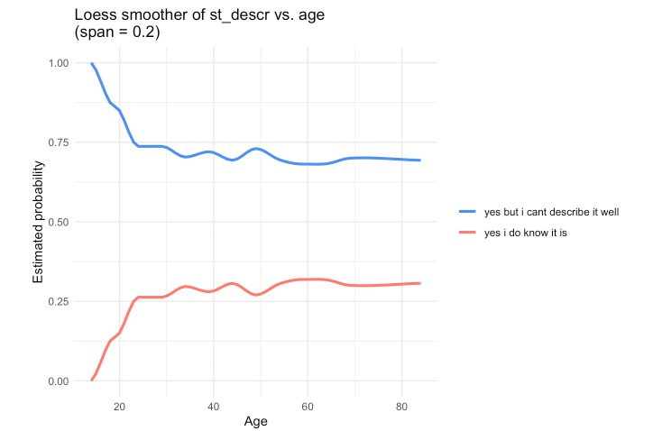

Figure 6: The probabilities of describing the standard (lower line) and familiarity with the concept but unable to define it

One additional issue that can be raised from the quantitative data and the qualitative comments is that the older teenagers are the age cohort that is one least likely to know what StCanE is. Only 10 of the 116 youngsters aged 15-19-years and socialized in Canada (162 overall, including newcomers) know what “Standard Canadian English” is, which raises the question how English is taught at Canadian schools, without using this key concept in pluricentric theory. It may explain – lack of teaching this concept in school – why the monolingual speakers (Figure 5) are less likely to have heard about StCanE than multilinguals, which leaves the monolinguals potential for linguistic identity formation untapped.

**“Canadian way” of speaking**

Another way of gauging the awareness of StCanE is to ask about a “Canadian way” of speaking. Without using linguistic terminology of standard varieties, the respondents answer with a personal assessment or impression. Figure 7 shows the results for Canadian residents and those those who spent their formative years in Canada (left). Those growing up in Canada see consistently more a “Canadian way of speaking”. Figure 7 (right) divides the “formative years” on the left by gender, suggesting that females overall play a more important role than males in that process, with non-binaries numerally too weak to make a difference.

|  |  |
| --- | --- |
|  |  |
| Fig. 7: “Canadian way of speaking” - Canadian residents and those who grew up in Canada | Genders and “Canadian way of speaking” |

The recognition of this expression of linguistic autonomy seems to be predominantly female-led. In terms of age, we see a slight decrease among the younger cohorts, which to a degree will correlate with education: as we will see below, the more educated a respondent is, the more likely they are to recognize Standard Canadian English.

**Standard Language Attitude Index (SLAI)**

A further attempt to gauge awareness of standard varieties is via composite Index SLAI. The original concept of combining five factors was reduced to four due to low internal consistency with the last factor (Have you heard the term “Standard Canadian English”), which was treated separately above. SLAI averages the following four variables at the level of the individual respondent.[4]

* **Spell_uni**: Do you think Canadian university departments should encourage Canadian

English spelling in academic work?

* **spell**: Do you think that Canadian spelling is important (e.g. "colour" instead of

"color", "familiarize" not "familiarise")?

* **distinct**: In your opinion, is Canadian English a distinct kind of English (e.g. similar to

American English being distinct from British English)?

* **cdn_way**: In your opinion, is there a Canadian way of speaking English?

An internal consistency test of the SLAI revealed an overall Cronbach 𝛼 of 0.7 suggesting that the index meets the consistency threshold for research work proposed by Nunnally & Bernstein (1994).

Figure 8 shows the distribution of SLAI with Education as explanatory variable, \a highly significant effect (p<0.05 for all education levels) Figure 8 shows that recognition of Standard Canadian English increases regularly with highest level of education completed.

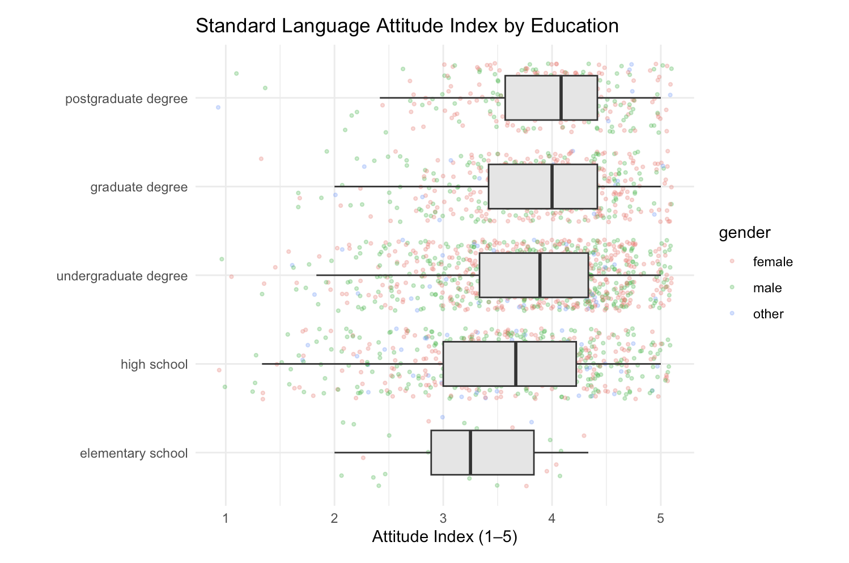

Figure 8: SLAI and Education

When we introduce Gender into the mix, which tested as significant, a more nuanced picture emerges that allows us to distinguish between English monolingual speakers and multilingual speakers on another level. Among the monolinguals, shown in Figure 9 on the left, gender is more important as a predictor than among the multilinguals (shown on the right). Specifically, monolingual (young) females with only an elementary school education are considerably more positive towards Standard Canadian English, expressed via a higher SLAI, than their male counterparts. A gap that is second widest among those with a graduate education. In the undergraduate segment, non-binary students are more sceptical than both males and females.

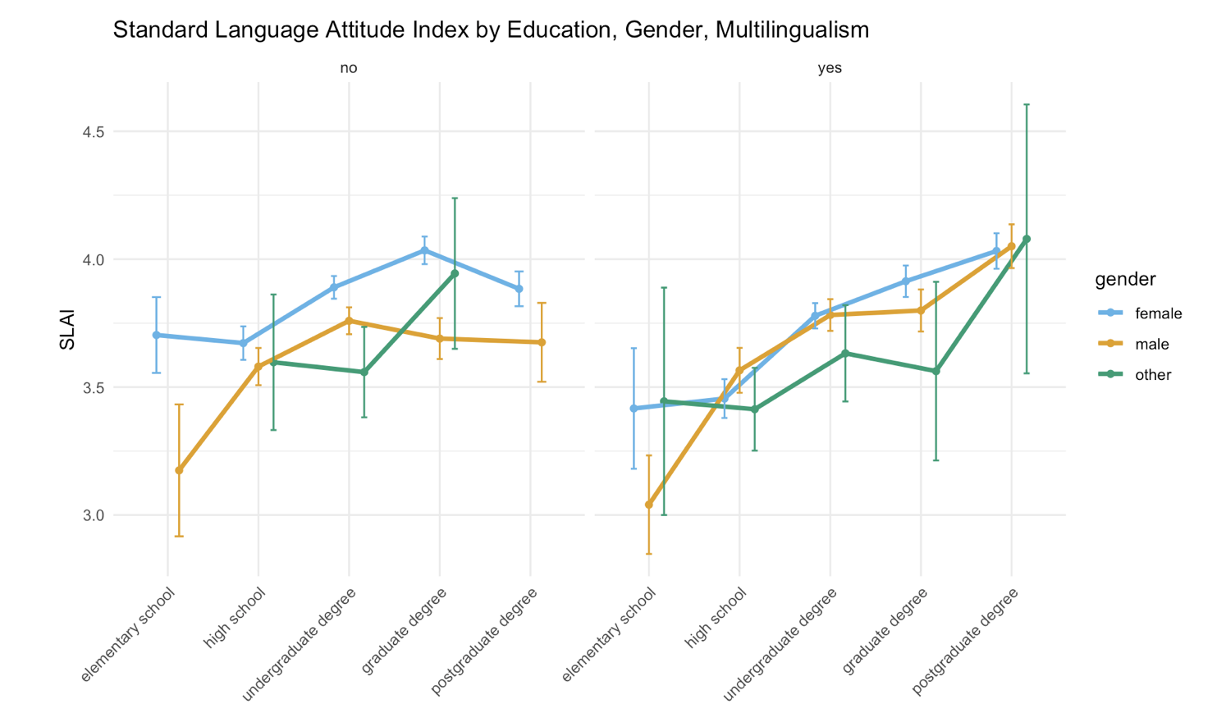

Figure 9: SLAI, education and gender

For the multilinguals (right), males and females align much more closely with one another, with the notable exception of elementary schoolers, where males are again more sceptical. Note that non-binaries are, from high-school on, more sceptical, except those with a postgraduate degree, which have a slightly higher SLAI than both females and males in their cohort.

While the difference between male and female participants is clearest among respondents with *either* elementary education *or* those with a graduate degree, the countertrends for males on the one hand and females on the other can be shown in Figure 10:

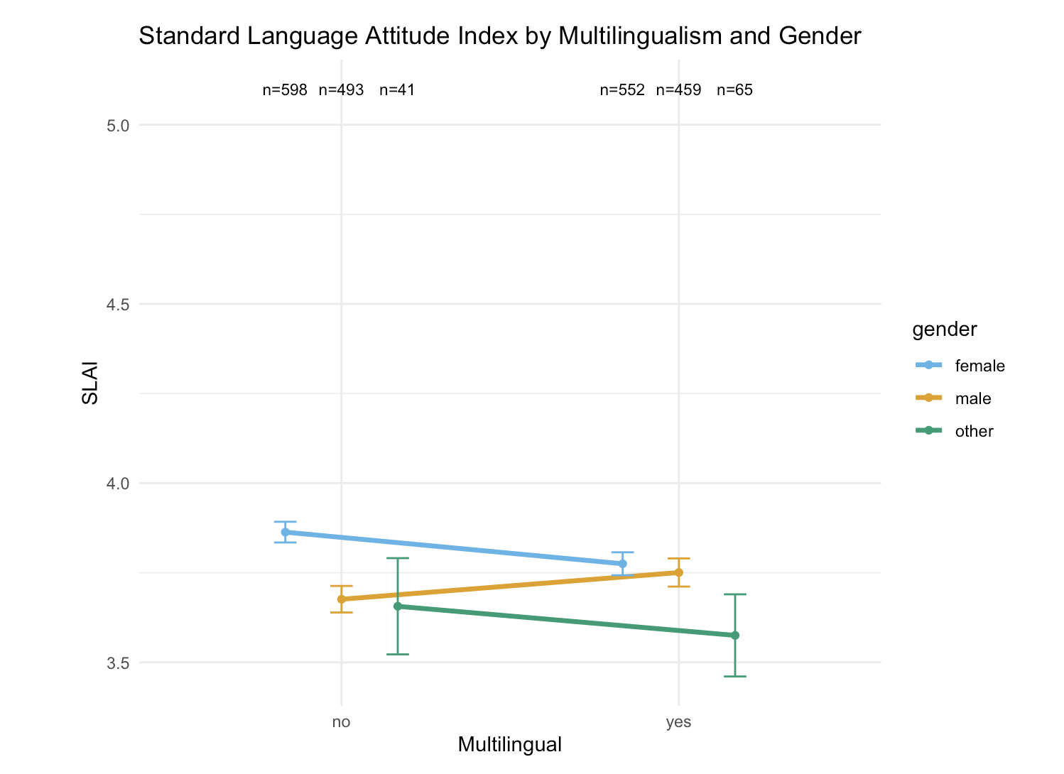

Figure 10: SLAI, Multilingualism and Gender

In monolinguals females have a higher SLAI than their multilingual peers. The same holds for non-binary speakers. For men, however, the trend is reverse, as multilingual speakers have a higher SLAI than monolingual speakers, which leads to a split between males and females as a significant variable overall.

The effects explored here were entered into a linear regression model predicting respondent’s aggregate values for SLAI. Region, gender and education were found to make highly significant predictions, as shown in Table XX below.

Table 1. Model terms predicting SLAI and their statistical significance values.

**“Ethnic Orientation Index” and “English Use Index”**

Given that speakers’ status as multilingual speakers has effects on the recognition of StCanE, the effect of a speaker’s ethnic group and one’s orientation towards that group – or lack thereof – seemed like a reasonable choice for further exploration. Ethnic heritage group membership has been a recent focus in work on CanE (e.g. Nagy 2024, Nagy, Hoffman & Walker 2020), going back to at least Hoffman & Walker (2010), whose concept of an EOI – Ethnic Orientation Index – was adapted for written questionnaire surveys such as ours and scaled down from 32 to just five questions:

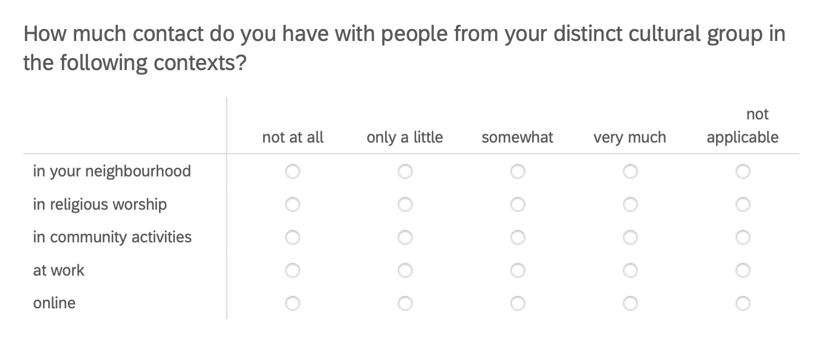

Figure 11: EOI questions in 2023 written questionnaire

1. Canada-US Trade Agreement in 1988, NAFTA in 1994, the European Union 1993 and the founding of the World Trade Organization in 1995
2. <https://www.academia.edu/129153656/>
3. In terms of significance, only the underlined provinces show at the 95% confidence interval **🡸 adverbial placement?!** a significant difference between the “yes” and “no” categories. In these six provinces, however, exposure to the term is statistically more likely than not having heard of it.
4. Questions with answer choices on a four-point Likert scale were rescaled to match the spread of a five-point scale to enable us to meaningfully average the four responses.